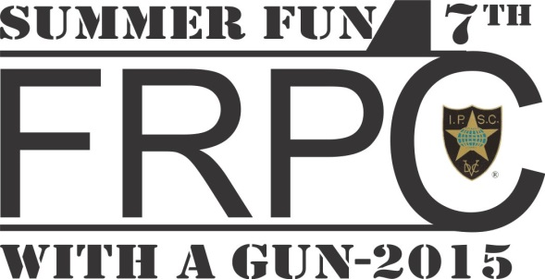

Frontenac Rifle and Pistol Club
P.O. Box 144
Kingston, Ontario
K7L 4V6

31 March 2015

Your name
Address
City, Province
Postal code

Summer Fun 2014 Invitation Letter

Dear IPSC shooter,

You are cordially invited to participate in the IPSC Ontario “Summer Fun 2015,” a Level III IPSC match to be held at the Frontenac Rifle and Pistol Club, 1096 McAdoo’s Lane, Kingston, Ontario, K7T 2Y3 on 18-21 June 2015 inclusive.

We look forward to seeing at the match!

Bernard DeGagné
Match Director

